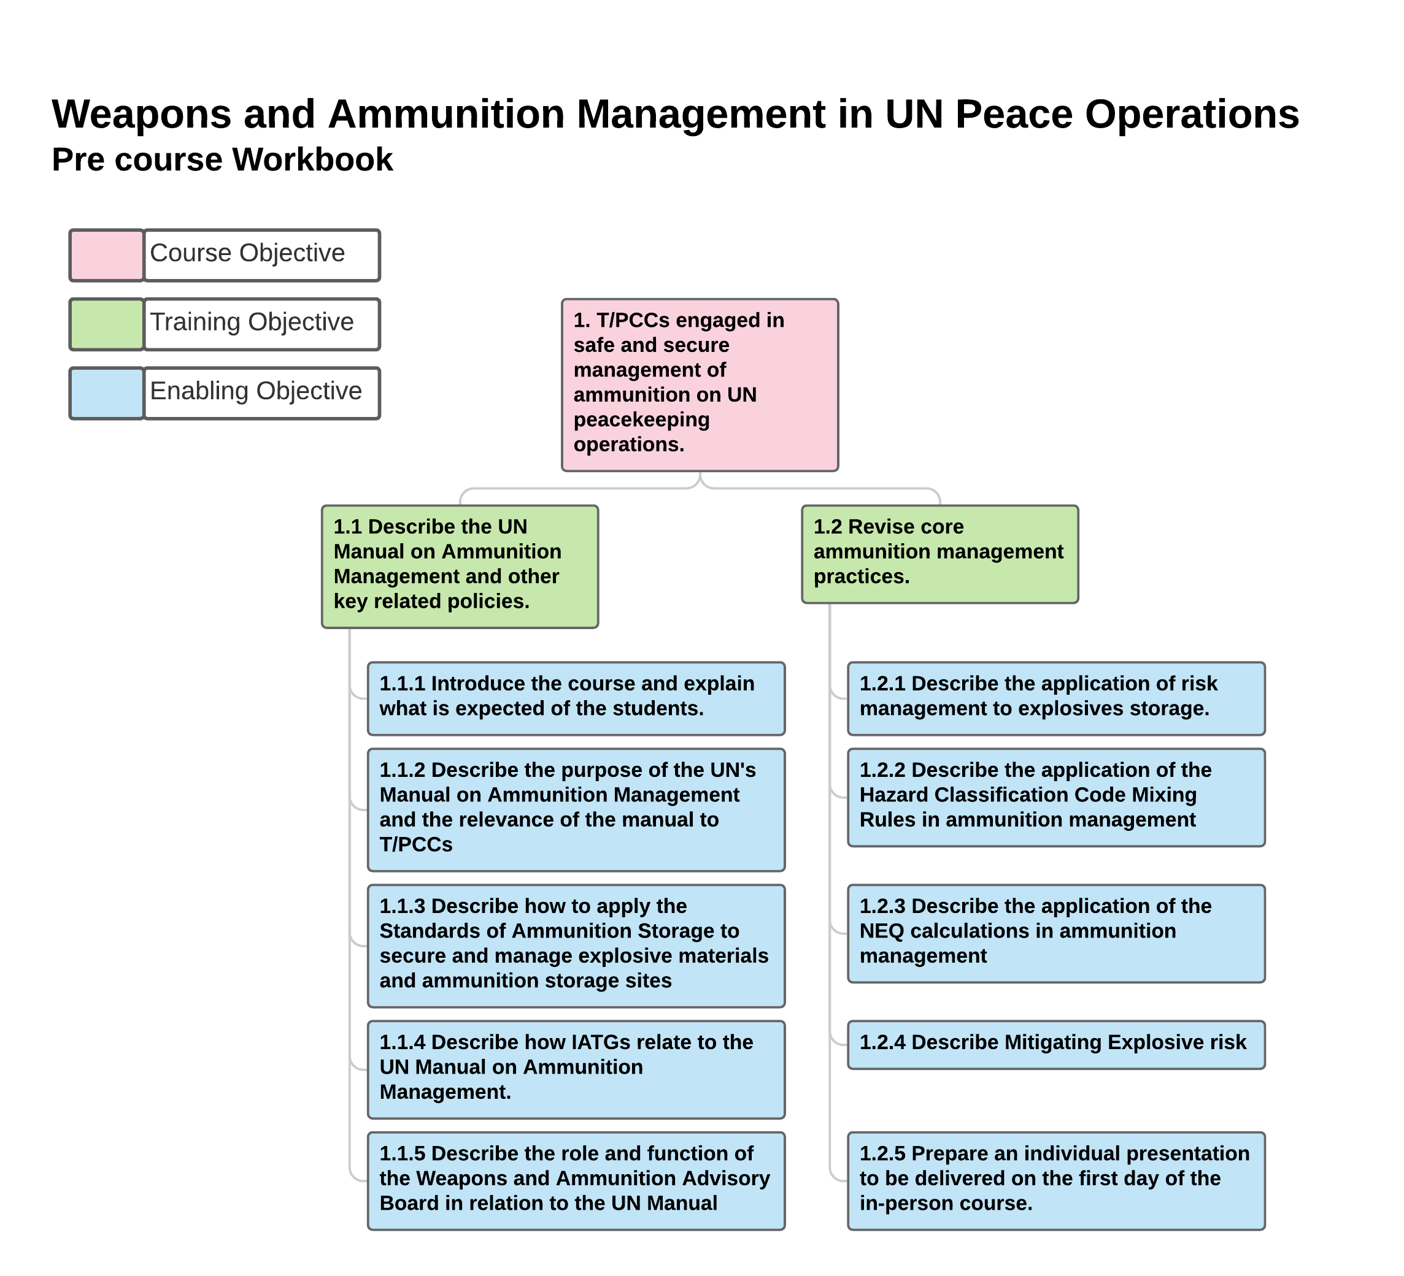

**Section 1. Lesson Specification**

**Course Details:**

|  |  |
| --- | --- |
| **Course Title:** | **Weapons and Ammunition Management in UN Peace Operations.**  Pre course workbook |
| **Course Objective** | 1. T/PCCs engaged in safe and secure management of ammunition on UN peacekeeping operations. |
| **Training Objective(s):** | * 1. Describe the UN Manual on Ammunition Management and other key related policies   1.2 Revise core ammunition management practices |

**Lesson Details:**

|  |  |
| --- | --- |
| **Lesson Number and Title:** | Pre course workbook |
| **Type of Lesson / Session:** | Student self-supported study |
| **Duration:** | Total 21 hours |

**Enabling Objectives, Key Learning Points & Training Outcomes:**

|  |  |
| --- | --- |
| **Enabling Objectives:**  1.1.1 Introduce the course and explain what is expected of the students.  1.1.2 Describe the purpose of the UN's Manual on Ammunition Management and the relevance of the manual to T/PCCs  1.1.3 Describe how to apply the Standards of Ammunition Storage to secure and manage explosive materials and ammunition storage sites  1.1.4 Describe how IATGs relate to the UN Manual on Ammunition Management  1.1.5 Describe the role and function of the Weapons and Ammunition Advisory Board in relation to the UN Manual  1.2.1 Describe the application of risk management to explosives storage.  1.2.2 Describe the application of the Hazard Classification Code Mixing Rules in ammunition management  1.2.3 Describe the application of the NEQ calculations in ammunition management  1.2.4 Describe Mitigating Explosive risk  1.2.5 Prepare an individual presentation to be delivered on the first day of the in-person course | |
| **Key learning Points (KLPs):**  There are separate KLPs for each Enabling Objective. These are listed in the workbook and shown in Annex A. | |
| **Performance Statement:** | *By the end of the lessons the students will...*  Be prepared to attend the Weapons and Ammunition Management in UN Peace Operations in-person training. |
| **Assessment Criteria:** | Students are assessed on their project presentations delivered on day 1 of the in-person training, and their responses to the questions in the workbook.  Presentations and workbook answers should be used by instructors to assess baseline level of knowledge, skills and experience of each student, identify any areas that require further support and tailor the in-person training accordingly. |

**Resource requirements:**

|  |  |
| --- | --- |
| **Instructor to student ratio:** | Maximum class size 15. |
| **Interpreters:** | Workbook may need to be translated in advance  Student’s workbook responses may need to be translated once received |
| **Training Facilities & Equipment:** | n/a |
| **Instructional tools & materials** | n/a |
| **Student Resources:** | Minimum requirement:   * Each student needs a copy of the workbook (emailed as a pdf attachment) or posted as a paper copy   Where possible, students should also have access to:   * [UN Manual on Ammunition Management](http://dag.un.org/bitstream/handle/11176/401027/2020%20Manual%20on%20Ammunition%20Management%20pdf.pdf?sequence=1&isAllowed=y). * [UN Weapons and Ammunition Management Policy](http://dag.un.org/bitstream/handle/11176/400906/Weapons%20and%20Ammunition%20Policy.pdf?sequence=2&isAllowed=y) * [International Ammunition Technical Guidelines (IATG)](https://unsaferguard.org/)   + www.unsaferguard.org * [Modular Small-arms-control Implementation Compendium (MOSAIC)](http://dag.un.org/bitstream/handle/11176/400906/Weapons%20and%20Ammunition%20Policy.pdf?sequence=2&isAllowed=y)   + www.un.org/disarmament/convarms/mosaic/ |
| **Training Safety Points:** | Students should take regular breaks |
| **Key Reference Documents:** | * [UN Manual on Ammunition Management](http://dag.un.org/bitstream/handle/11176/401027/2020%20Manual%20on%20Ammunition%20Management%20pdf.pdf?sequence=1&isAllowed=y). * [UN Weapons and Ammunition Management Policy](http://dag.un.org/bitstream/handle/11176/400906/Weapons%20and%20Ammunition%20Policy.pdf?sequence=2&isAllowed=y) * [International Ammunition Technical Guidelines (IATG)](https://unsaferguard.org/)   + www.unsaferguard.org * [Modular Small-arms-control Implementation Compendium (MOSAIC)](http://dag.un.org/bitstream/handle/11176/400906/Weapons%20and%20Ammunition%20Policy.pdf?sequence=2&isAllowed=y)   + www.un.org/disarmament/convarms/mosaic/ |

**SECTION 2: LESSON PLAN**

**Executive summary:**

The pre-course workbook is the first component of the Weapons and Ammunition Management in UN Peace Operations training. **It must be completed before attending the in-person training component.** The workbook is intended to prepare students for the in-person course, focusing on familiarisation with and understanding of:

* The contents of the UN Manual on Ammunition Management, UN Weapons and Ammunition Policy, IATGs and MOSAIC.
* Elements of fundamental knowledge on weapons and ammunition management.

**Setup:**

Student self-supported study

Students should receive their copy of the pre-course workbook in sufficient time to complete it before the in-person training, acknowledging other commitments students have.

The workbook instructs students to select their topic for the project presentation from the list provided, although instructors may wish to allocate a topic to each student when the workbooks are distributed to achieve an even spread of topics across the group.

The workbook must be **completed and submitted on day 1 of the in-person component.** Alternatively, instructors could request students to submit their completed workbooks before the in-person course, although only if students have sufficient time and resources to be able to email/post.

**Conduct:**

The workbook is divided into 2 sections, each with several sub-sections that relate to specified elements of the key reference documents:

|  |  |
| --- | --- |
|  | Page |
| **Prior experience** | 5 |
| List of Acronyms | 6 |
| Prior experience of UN manual on Ammunition Management | 8 |
| **Section 1: UN Manual on Ammunition Management and other key related policies** |  |
| 1.1 UN Manual on Ammunition Management and other key related policies | 9 |
| 1.2 Standards of Weapon and Ammunition Storage in UN Operations | 15 |
| 1.3 International Ammunition Technical Guidelines | 19 |
| 1.4 Weapons and Ammunition Advisory Board | 23 |
| **Section 2: Core Ammunition Management practices** |  |
| 2.1 Introduction to Risk management | 27 |
| 2.2 Explosive Hazard Classification Code | 31 |
| 2.3 Calculating Explosive Risk | 34 |
| 2.4 Mitigating Explosive risk | 38 |
| 2.5 Project | 42 |
| Glossary of Terms and Definitions | 43 |

To assist learning each sub section has a ‘knowledge check’ section (fact based questions) and an ‘apply what you know’ section (an opportunity to apply what has been learnt, combined with existing knowledge, skills and experience).

**Estimated time:** 21 hours of self-supported study including the preparation of a presentation to be delivered by students on day 1 of the in-person course.

**Reading**: Each sub-section has recommended reading to support learning (a selection of pages from the UN Manual on Ammunition Management or a section of the IATGs). Students are strongly encouraged to complete the recommended reading where possible. However, if a student does not have access to the reference documents it is still possible to complete this workbook.

**Student support**: Where possible, instructors should make themselves available to students if they have any questions while completing the pre course workbook.

**Assessment**: Presentations and workbook answers should be used by instructors to assess baseline level of knowledge, skills and experience of each student, identify any areas that require further support and tailor the in-person training accordingly.

**Annex A – KLPs per section**

